~Asia-Japan-Mirror-Edo-Squirrel and Grapes

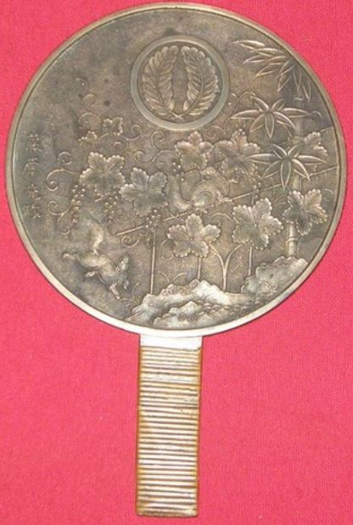

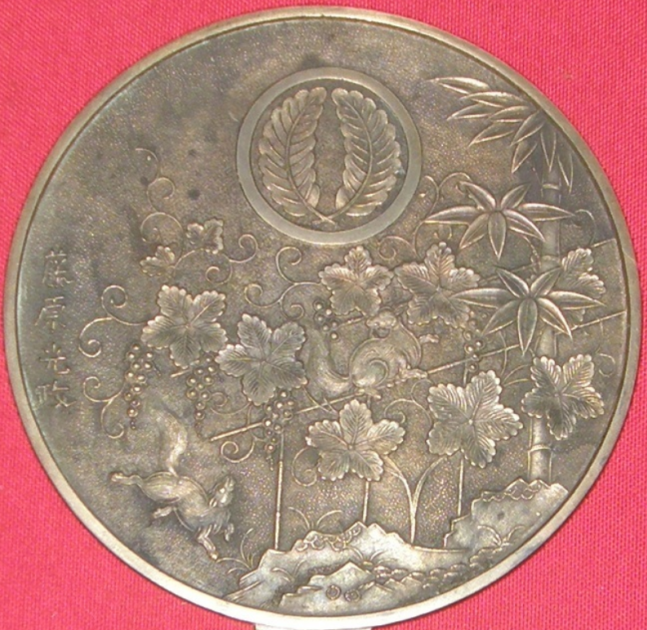

# Signed w/ Crest